INSTALLATION GUIDE
DATABASE SETUP
Step 1:
Start the DB2 Control Centre and right click on All Databases.

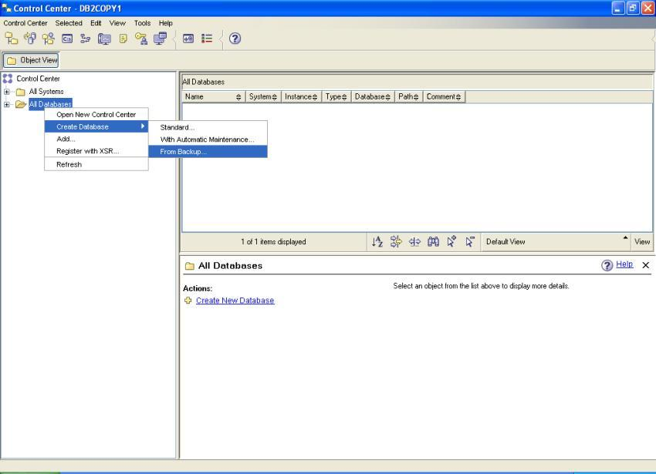
Figure 1: Create Database From Backup

Step 2:
Start the DB2 Control Centre and right click on All Databases. Enter details as follows and click Next:
Database being restored: BLOODDON
Name of the Database: BLOODDON
Location of the database after restore: Enter the path (for eg: F:\ )
Location of logs after restore: Enter the path for logs (eg: C:\Logs)

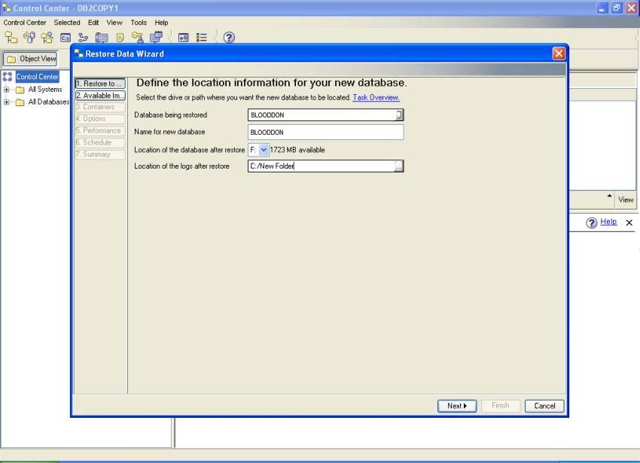
Figure 2: Restore Data Wizard Page 1

Step 3:
Enter Details as follows and Click Finish:
Media Type: File System
Add: Unzip the Database Backup file that is attached with the documentation and give its path in Location
Date: March 22, 2012.
Time: 11:00:56

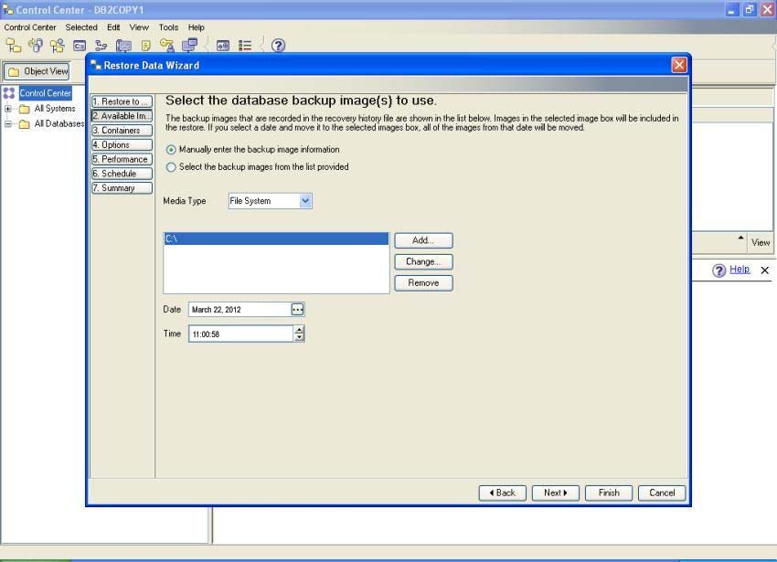
Figure 3: Restore Data Wizard Page 2

The database has been successfully installed. It can be checked under All Databases Tab as BLOODDON.

APPLICATION SETUP
Step 1:
Right Click the WebShpere Application Server v6.1 and select
Run Administrative console:

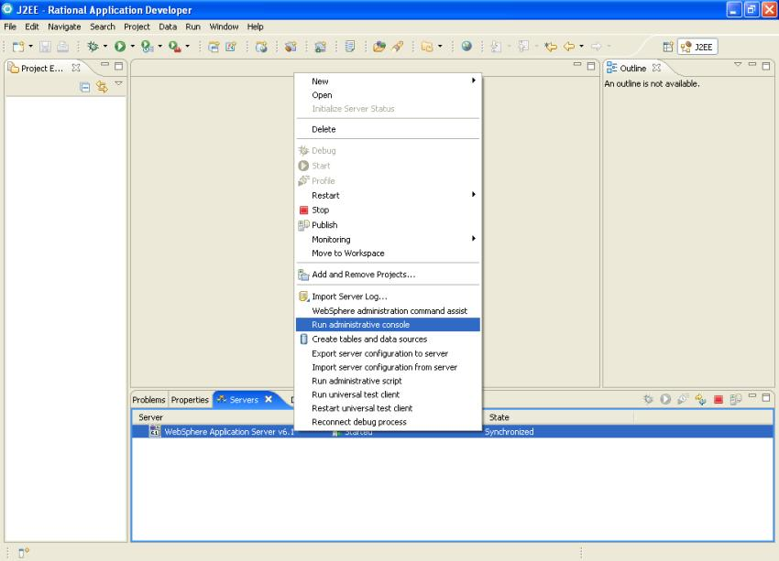
Figure 4: WebShpere Application Server v 6.1

Step 2:
Expand the Applications Tab and select Install new Application.

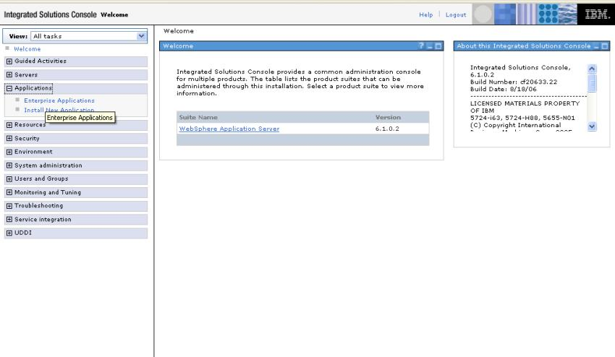
Figure 5: Administrative Console

Step 3:
Enter the details as follows and click Next:

Path to the Application: Select Local File System and enter the full path of the war file BLOODDON.war eg. C:\Documents and Settings\Arun\Desktop\BLOODDON.war

Context root: Enter BLOODDON as context root.

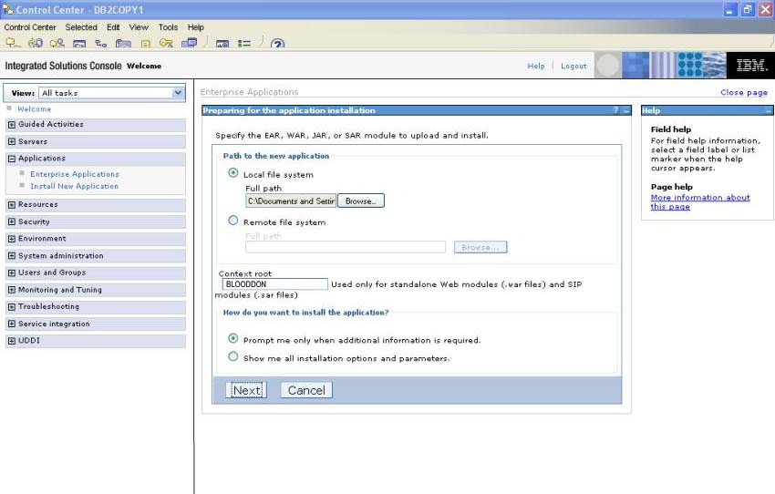
Figure 6: Install New Application Step 1.

Step 4:
Accept all default details and click Next:

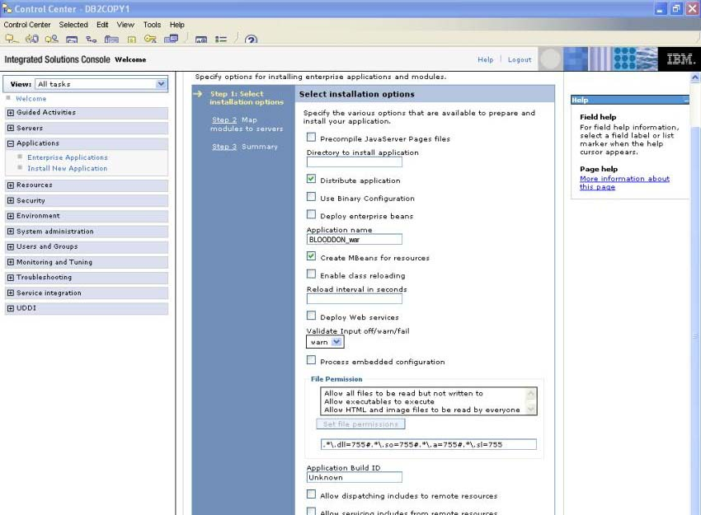
Figure 7: Install New Application Step 2

Step 5:
Select BLOODDON Module and click Next:

Step 6:
Verify all details in Summary and click on Finish:

Step 7:
The application will be installed. Click on Save to save changes in the Master configuration.

Step 8:
Expand the Applications Tab and select Enterprise Applications.

Step 10:
The application BLOODDON_war has been successfully installed.

